**Phase 2 Documentation: Org Setup & Configuration**

**Project:** Supply Chain Traceability & Inventory Management System

**Purpose:** This phase established the secure, foundational structure of the Salesforce organization. We configured the environment, created necessary user profiles, defined security boundaries, and created core custom fields required for the subsequent data modeling phase.

## **1. Environment and Project Initialization**

| **Configuration Item** | **Detail** | **Rationale** |
| --- | --- | --- |
| **Org Type** | Developer Edition (Trial) | Provides a full feature set for development, including necessary limits for Apex and Lightning Web Components. |
| **Admin User** | System Administrator Profile | Used for initial setup, package installation, and metadata deployment. |

### **Confirmation of Developer Environment**

This project was built within a dedicated Developer Edition org to ensure the required pre-configuration was available and isolated from other projects.

## **2. User Setup and Profiles**

We created two custom profiles to enforce the separation of duties and the **Principle of Least Privilege (PoLP)**. This ensures users only have the necessary access to their core objects.

### **Custom Profiles Created**

| **Profile Name** | **Based On** | **Primary Access** |
| --- | --- | --- |
| **Inventory Manager** | Standard User | Create/Edit/Delete access on Shipment__c and Retail_Location__c. |
| **Quality Assurance Specialist** | Standard User | Read-Only access to all transaction objects (Lot__c, Shipment__c). Primary focus on using the Traceability LWC. |

**Security View:** Both profiles were cloned from the **Standard User** profile, and unnecessary standard object permissions were removed to maintain a lean environment.

**INVENTORY MANAGER PROFILE :-**

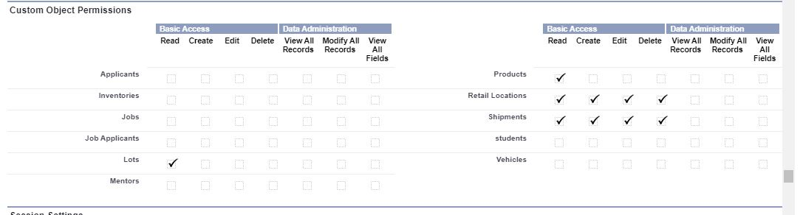

* **QUALITY ASSURANCE SPECIALIST ➖**

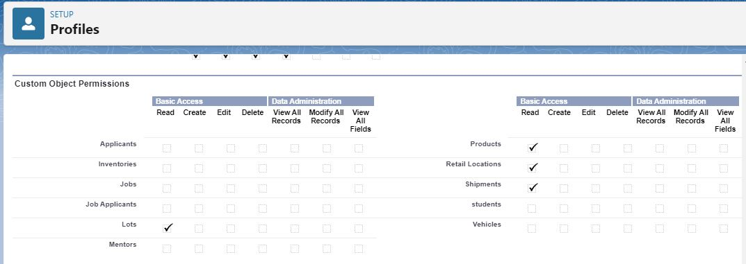

**3. Security Model (Roles and OWD)**

To implement the requirement for regional data separation, a Role Hierarchy was established, and the Organization-Wide Defaults (OWD) were set to restrict default visibility.

### **Role Hierarchy Setup**

The hierarchy was structured to allow managers visibility over their regions while ensuring peer-to-peer data remains hidden.

1. **CEO (Top Level)**
2. **Inventory Director**
3. **Regional Manager - East**
4. **Regional Manager - West**

### **Organization-Wide Defaults (OWD)**

For the most sensitive objects, the OWD was configured as follows:

| **Object** | **Default Internal Access** | **Rationale** |
| --- | --- | --- |
| **Retail_Location__c** | Private | Restricts visibility of store locations, ensuring managers can only see locations within their territory (Enforced via Sharing Rules). |
| **Shipment__c** | Public Read Only | Allows all managers to see that a shipment occurred, but restricts editing to the owner/manager. |

## **4. Custom Field Preparation**

Prior to Phase 3 (Data Modeling), critical fields needed by later Apex logic and LWC components were defined.

### **Key Custom Fields Created**

| **Object** | **Field Label** | **API Name** | **Data Type** | **Purpose in Project** |
| --- | --- | --- | --- | --- |
| **Lot** | Barcode | Barcode__c | Text (Unique) | Used by the Traceability LWC for quick lookup and item history. |
| **Lot** | Current Inventory | Current_Inventory__c | Number | Stores the remaining stock per lot (Decremented by Apex Trigger). |
| **Shipment** | Quantity | Quantity__c | Number | Stores the amount shipped for use in trigger calculations. |

**Barcode Field Confirmation:** The Barcode__c field on the Lot__c object was set as **Unique** to prevent duplicate entries and ensure reliable search results for the traceability scanner.